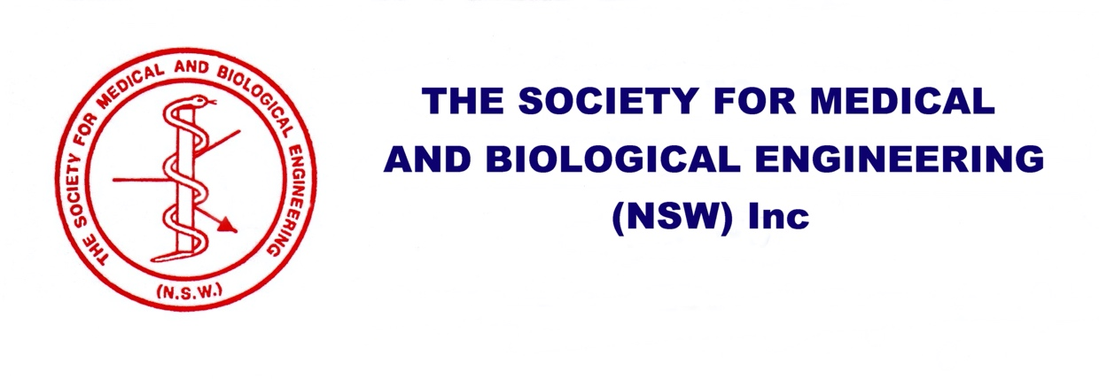
ABN: 77 878 685 919
PO Box 4144, Candelo, NSW, 2550

Application for Membership / Membership Renewal
Name: ________________________________________ Mobile: __________________________
Organisation or Affiliation: ____________________________
Email: _____________________________________________
Postal Address: ________________________________________ Postcode: ___________________

Membership year: 1 July 2025 to 30 June 2026
(Note: Membership includes discounted registration to the annual SMBE conference)
Membership Category | Conditions | Fee (AUD) | Select Category  & Enter Amount
Ordinary Membership |  | $50.00 each
Group Membership | Group of 2 – 4 members | $40.00 each
Group Membership | Group of 5 – 9 members | $30.00 each
Group Membership | Group with more than 10 members | $25.00 each
Student Membership | Fulltime students only (proof required) | $25.00 each
Total - Don’t pay now! We will send you an Invoice for payment by EFT |  |  | $
Group membership: Please use a separate page for each member with full details
Please check your address details and e-mail address are correct so that we may advise you of upcoming events, and thank you for your support of SMBE NSW Inc.
Please email completed form(s) to: memberships@smbensw.org.au
For more information contact:
Bruce Morrison (President) by e-mail to: president@smbensw.org.au or
Bob Smith (Secretary/Treasurer) by e-mail to: treasurer@smbensw.org.au

